

**King Saud University**

**College of Computer and Information Sciences**

**Computer Science Department**

*CSC 340 – Assignment (2) report*

**Prepared by:**

(**8**) | Faisal Khalid Al-Zahrani | 441101794

**Supervised by:**

Dr. Wesam A. Hatamleh

2nd semester 1444

2022

**Section: 53505**

**Picture of the lexical.l code**

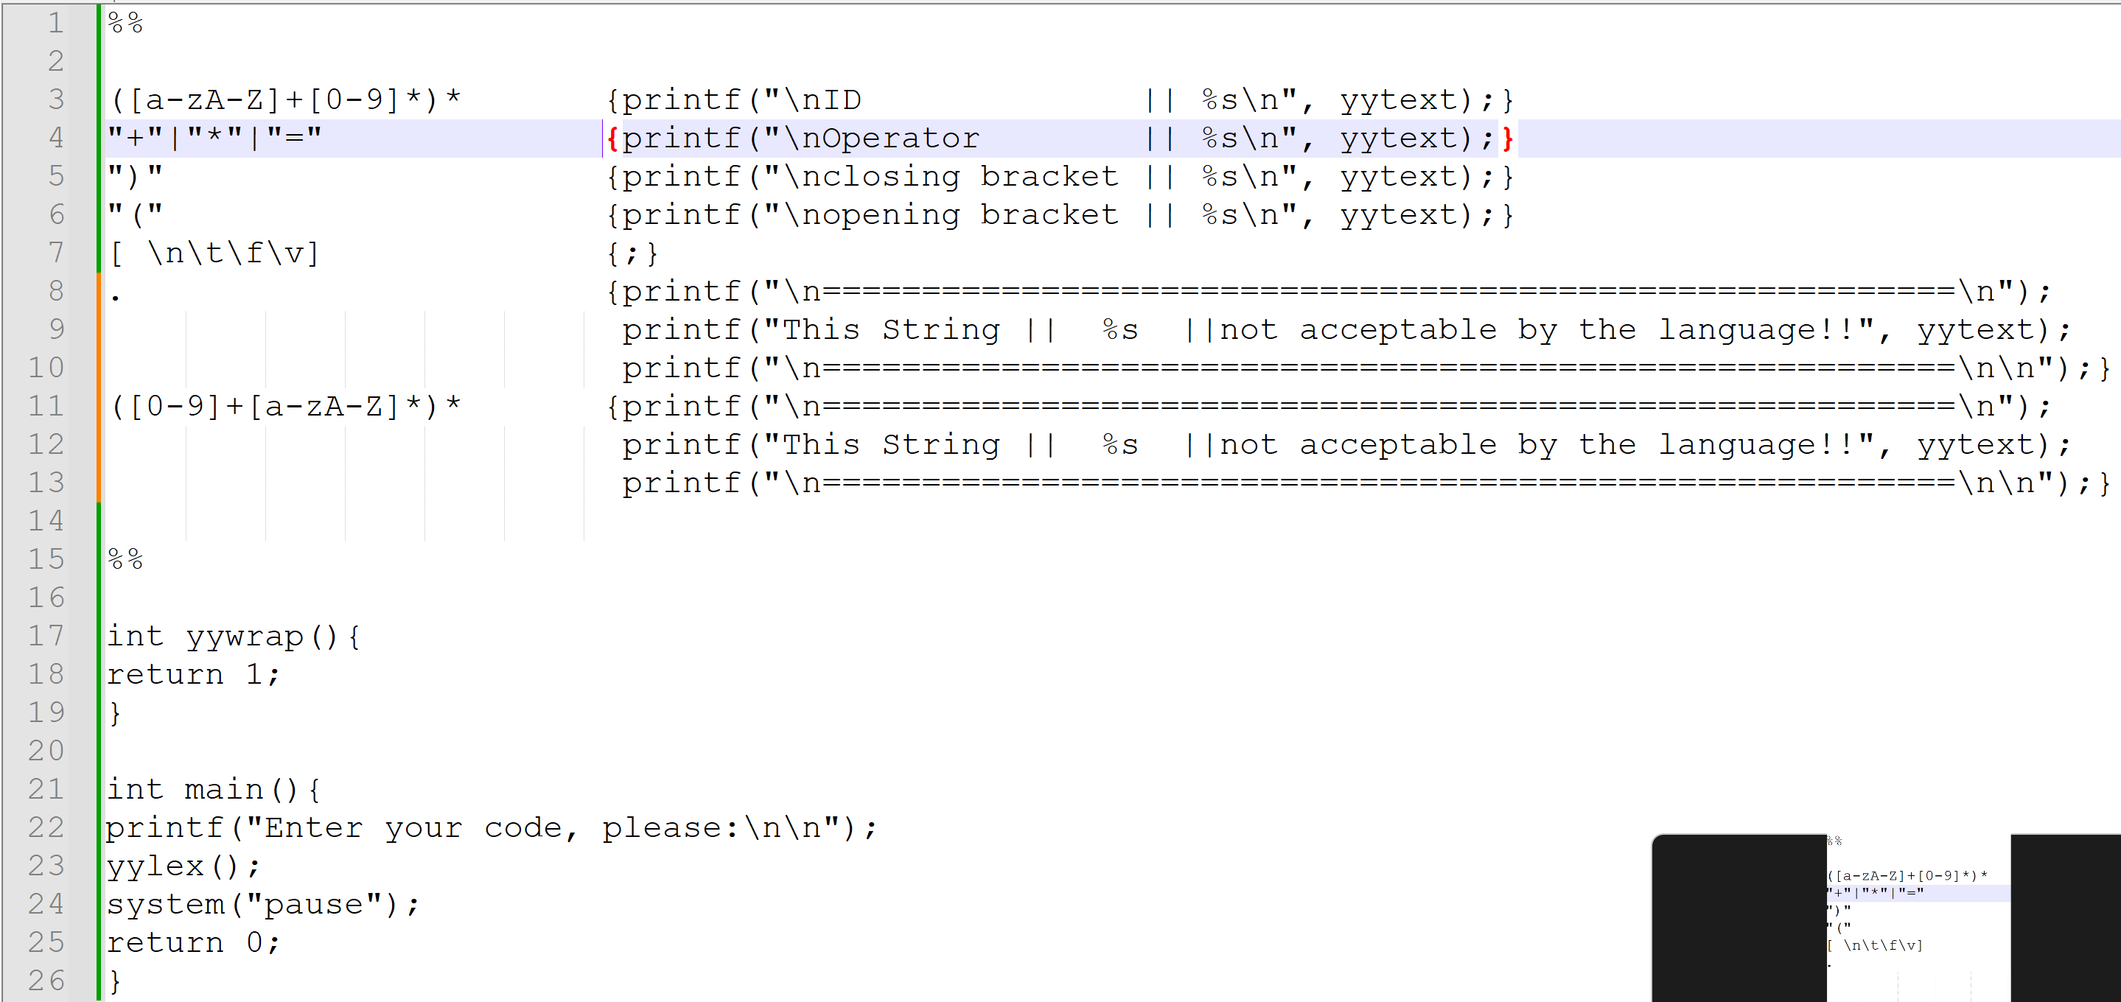

**Lexical.l Code**

**%%**

**([a-zA-Z]+[0-9]*)* {printf("\nID || %s\n", yytext);}**

**"+"|"*"|"=" {printf("\nOperator || %s\n", yytext);}**

**")" {printf("\nclosing bracket || %s\n", yytext);}**

**"(" {printf("\nopening bracket || %s\n", yytext);}**

**[ \n\t\f\v] {;}**

**. {printf("\n=========================================================\n");printf("This String || %s ||not acceptable by the language!!", yytext);printf("\n=========================================================\n\n");}**

**([0-9]+[a-zA-Z]*)* {printf("\n=========================================================\n");printf("This String || %s ||not acceptable by the language!!", yytext);printf("\n=========================================================\n\n");}**

**%%**

**int yywrap(){**

**return 1;**

**}**

**int main(){**

**printf("Enter your code, please:\n\n");**

**yylex();**

**system("pause");**

**return 0;**

**}**

**Picture of the output, THERE IS ( 1 ) PICTURE**

